SOFTWARE REQUIREMENTS SPECIFICATION

**For**

**Inventory Management System**

**Prepared by:-**

*ABDUL RIJAS AHAMMED-722822104005*

*ASHWIN M-722822104024*

*CIBIRAJ C-722822104034*

# Introduction

## Purpose

The main objective of this document is to illustrate the requirements of the project Inventory Management system. The document gives the detailed description of the both functional and non-functional requirements proposed by the client.The purpose of this project is to provide a friendly environment to maintain the details of product and user.The main purpose of this project is to maintain easy circulation system using computers and to provide different reports. This project describes the hardware and software interface requirements using ER diagrams and UML diagrams.

## Document Conventions

* + - Entire document should be justified.
    - Convention for Main title

Font face: Times New Roman Font style: Bold

Font Size: 14

* + - Convention for Sub title

Font face: Times New Roman Font style: Bold

Font Size: 12

* + - Convention for body

Font face: Times New Roman Font Size: 12

## Scope of Development Project

The scope of the project includes the development of a web-based Inventory Management System accessible to authorized users. The system will enable users to add, modify, and remove products, process orders, and maintain accurate inventory levels. The purpose of the Inventory Management System (IMS) is to provide an efficient and user-friendly application for tracking and managing inventory items, facilitating seamless product management, order processing, and real-time inventory tracking. The system will comprise modules for user authentication, product management, order processing, and inventory tracking. Users will have defined access levels to ensure secure and controlled management of inventory.

The project can be easily implemented under various situations. We can add new features as and when we require, making reusability possible as there is flexibility in all the modules.

The language used for developing the project is Java as it is quite advantageous than other languages in terms of performance, tools available, cross platform compatibility, libraries, cost (freely available), and development process.

## Definitions, Acronyms and Abbreviations

JAVA -> platform independence SQL-> Structured query Language ER-> Entity Relationship

UML -> Unified Modeling Language

IDE-> Integrated Development Environment SRS-> Software Requirement Specification

## References

* + - Products

 Software Requirements and Specifications: A Lexicon of Practice, Principles and Prejudices (ACM Press) by Michael Jackson

Software Requirements (Microsoft) Second EditionBy Karl E. Wiegers

Software Engineering: A Practitioner’s Approach Fifth Edition By Roger S. Pressman

* + - Websites

[**http://www.slideshare.net/**](http://www.slideshare.net/)

[**http://eproductily.net/doc/srs-inventory-management-system**](http://ebookily.net/doc/srs-library-management-system)

# Overall Descriptions

## Product Perspective

Use Case Diagram of Inventory Management System

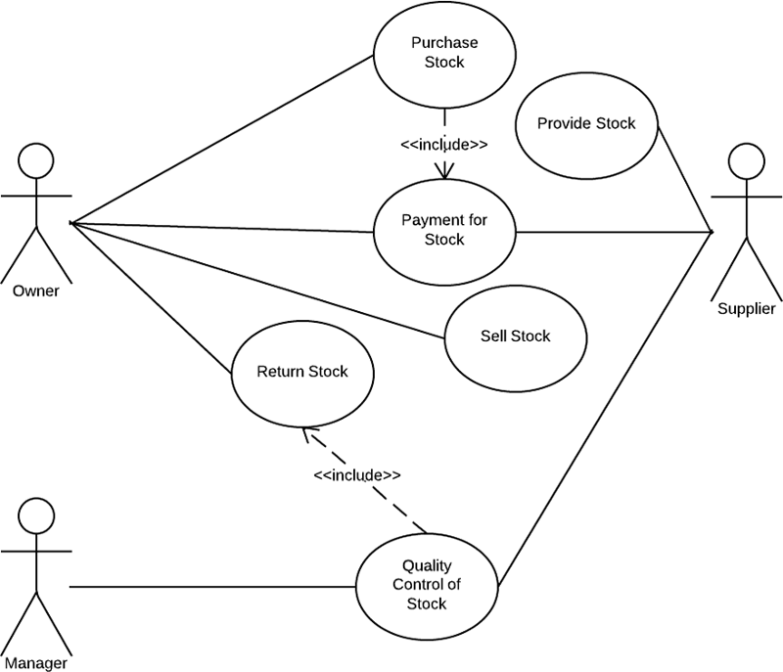

This is a broad level diagram of the project showing a basic overview. The users can be customers.This System will provide a search functionality to facilitate the search of resources. This search will be based on various categories viz. product name or the. Further the staff personnel can add/update the resources and the resource users from the system. The users of the system can request issue/renew/return of products for which they would have to follow certain criteria.

## Product Function

Entity Relationship Diagram of Inventory Management System

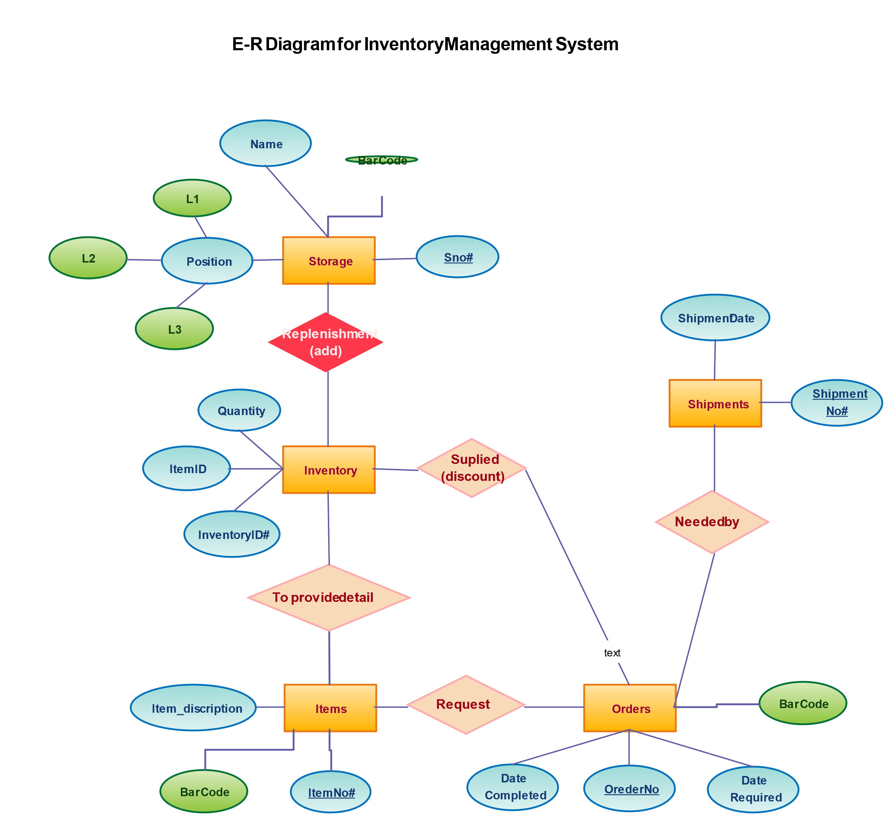

The Inventory System provides online real time information about the products available in the Inventory and the user information. The main purpose of this project is to reduce the manual work. This software is capable of managing Product Issues, Returns, Calculating/Managing Fine, Generating various Reports for Record-Keeping according to end user requirements. The Staff will act as the administrator to control members and manage products. The member’s status of issue/return is maintained in the inventory database. The member’s details can be fetched by the staff from the database as and when required. The valid members are also allowed to view their account information.

## User Classes and Characteristics

2.1 User Classes

The IMS will have the following user classes:

2.1.1 Administrator

Responsibilities:

Manage user accounts and permissions.

Configure system settings and preferences.

View and generate comprehensive reports.

Perform system maintenance and updates.

2.1.2 Inventory Manager

Responsibilities:

Add, update, and delete products from the inventory.

Monitor stock levels and set reorder points.

Generate and analyze inventory reports.

Track product movements and history.

2.1.3 Warehouse Staff

Responsibilities:

Receive and update incoming stock.

Fulfill orders and manage outgoing shipments.

Conduct physical inventory counts.

Locate and organize products within the warehouse.

2.1.4 Sales Staff

Responsibilities:

Check product availability and stock levels.

Place customer orders and process sales transactions.

Generate sales reports.

View customer information and order history.

2.2 User Characteristics

The users of the IMS are expected to possess the following characteristics:

Technological Proficiency:

Basic understanding of computer systems and software applications.

Ability to navigate and interact with the graphical user interface.

Comfortable using input devices such as keyboards and mice.

Domain Knowledge:

Familiarity with inventory management concepts and best practices.

Understanding of product lifecycle and supply chain processes.

Knowledge of relevant business operations.

Security Awareness:

Adherence to security protocols for user authentication and data access.

Awareness of the sensitivity of inventory and sales data.

Communication Skills:

Effective communication for collaboration among different user classes.

Ability to input and retrieve information accurately.

List of features available to both users and staff in an Inventory Management System (IMS). These features are categorized based on the roles mentioned earlier (Administrator, Inventory Manager, Warehouse Staff, and Sales Staff).

1. Common Features for All User Classes:

1.1 User Authentication and Authorization:

Secure login with username and password.

Role-based access control to restrict functionalities based on user roles.

1.2 Dashboard:

Overview of current inventory status, sales, and other relevant metrics.

1.3 Search and Filter:

Search functionality to quickly locate products based on various parameters (e.g., name, SKU).

Filter options to sort and organize inventory data.

2. Administrator Features:

2.1 User Management:

Add, edit, or deactivate user accounts.

Assign and manage roles and permissions.

2.2 System Configuration:

Configure system settings, preferences, and default values.

Manage notification preferences.

2.3 Reporting:

Access comprehensive reports on user activities, inventory levels, and system performance.

3. Inventory Manager Features:

3.1 Product Management:

Add, edit, or remove products from the inventory.

Set product categories and attributes.

3.2 Inventory Monitoring:

Real-time tracking of stock levels.

Automatic notification for low stock or stock-out situations.

3.3 Reporting:

Generate reports on product turnover, sales trends, and inventory valuation.

4. Warehouse Staff Features:

4.1 Stock Management:

Receive and update incoming stock.

Fulfill customer orders by picking and packing products.

4.2 Location Tracking:

Assign and track the location of products within the warehouse.

Conduct physical inventory counts.

4.3 Order Fulfillment:

Process outgoing shipments and update inventory accordingly.

Print packing slips and shipping labels.

5. Sales Staff Features:

5.1 Sales Transactions:

Check product availability and stock levels.

Create and process customer orders.

5.2 Customer Management:

View customer information and order history.

Manage customer accounts and preferences.

5.3 Reporting:

Access sales reports and analytics.

6. Common Features for All User Classes:

6.1 Notifications:

Receive alerts and notifications for critical events (e.g., low stock, order fulfillment).

6.2 Audit Trail:

Log and track changes made by users for accountability and traceability.

These features are foundational for an effective Inventory Management System, and the specifics can be further customized based on the unique requirements of the organization using the system.

Top of Form

## Operating Environment

The product will be operating in windows environment. The Management System is a website and shall operate in all famous browsers, for a model we are taking Microsoft Internet Explorer,Google Chrome,and Mozilla Firefox.Also it will be compatible with the IE 6.0. Most of the features will be compatible with the Mozilla Firefox & Opera 7.0 or higher version. The only requirement to use this online product would be the internet connection.

The hardware configuration include Hard Disk: 40 GB, Monitor: 15” Color monitor, Keyboard: 122 keys. The basic input devices required are keyboard, mouse and output devices are monitor, printer etc.

## Assumptions and Dependencies

The assumptions are:-

* + - The coding should be error free
    - The system should be user-friendly so that it is easy to use for the users
    - The information of all users, products and libraries must be stored in a database that is accessible by the website
    - The system should have more storage capacity and provide fast access to the database
    - The system should provide search facility and support quick transactions
    - The Inventory System is running 24 hours a day
    - Users may access from any computer that has Internet browsing capabilities and and Internet connection
    - Users must have their correct usernames and passwords to enter into their online accounts and do actions

The dependencies are:-

* + - The specific hardware and software due to which the product will be run
    - On the basis of listing requirements and specification the project will be developed and run
    - The end users (admin) should have proper understanding of the product
    - The system should have the general report stored
    - The information of all the users must be stored in a database that is accessible by the Inventory System
    - Any update regarding the product from the inventory is to be recorded to the database and the data entered should be correct

## Requirement

Software Configuration:-

This software package is developed using java as front end which is supported by sun micro system. Microsoft SQL Server as the back end to store the database.

Operating System: Windows NT, windows 98, Windows XP Language: Java Runtime Environment, Net beans 7.0.1 (front end) Database: MS SQL Server (back end)

Hardware Configuration:-

Processor: Pentium(R)Dual-core CPU Hard Disk: 40GB

RAM: 256 MB or more

## Data Requirement

The inputs consist of the query to the database and the output consists of the solutions for the query. The output also includes the user receiving the details of their accounts. In this project the inputs will be the queries as fired by the users like create an account, selecting products and putting into account. Now the output will be visible when the user requests the server to get details of their account in the form of time, date and which products are currently in the account.

# External Interface Requirement

## GUI

The software provides good graphical interface for the user and the administrator can operate on the system, performing the required task such as create, update, viewing the details of the product.

* + - It allows user to view quick reports like product Issued/Returned in between particular time.
    - It provides stock verification and search facility based on different criteria.
    - The user interface must be customizable by the administrator
    - All the modules provided with the software must fit into this graphical user interface and accomplish to the standard defined
    - The design should be simple and all the different interfaces should follow a standard

template

* + - The user interface should be able to interact with the user management module and a part of the interface must be dedicated to the login/logout module.

Login Interface:-

In case the user is not yet registered, he can enter the details and register to create his account. Once his account is created he can ‘Login’ which asks the user to type his username and password. If the user entered either his username or password incorrectly then an error message appears.

Search:-

The member or staff can enter the type of product he is looking for and the title he is interested in, then he can search for the required product by entering the product name.

Categories View:-

Categories view shows the categories of products available and provides ability to the staff to add/edit or delete category from the list.

Staff’s Control Panel:-

This control panel will allow staff to add/remove users; add, edit, or remove a resource. And manage lending options.

# System Features

The users of the system should be provided the surety that their account is secure. This is possible by providing:-

* User authentication and validation of members using their unique member ID
* Proper monitoring by the administrator which includes updating account status, showing a popup if the member attempts to issue number of products that exceed the limit provided by the policy, assigning fine to members who skip the date of return
* Proper accountability which includes not allowing a member to see other member’s account. Only administrator will see and manage all member accounts

# Other Non-functional Requirements

## Performance Requirement

The proposed system that we are going to develop will be used as the Chief performance system within the different campuses of the university which interacts with the university staff and customers. Therefore, it is expected that the database would perform functionally all the requirements that are specified by the university.

* + - The performance of the system should be fast and accurate
    - Inventory Management System shall handle expected and non-expected errors in ways that prevent loss in information and long downtime period. Thus it should have inbuilt error testing to identify invalid username/password
    - The system should be able to handle large amount of data. Thus it should accommodate high number of products and users without any fault.

## Safety Requirement

The database may get crashed at any certain time due to virus or operating system failure. Therefore, it is required to take the database backup so that the database is not lost. Proper UPS/inverter facility should be there in case of power supply failure.

## Security Requirement

* + - System will use secured database
    - Normal users can just read information but they cannot edit or modify anything except their personal and some other information.
    - System will have different types of users and every user has access constraints
    - Proper user authentication should be provided
    - No one should be able to hack users’ password
    - There should be separate accounts for admin and members such that no member can access the database and only admin has the rights to update the database.

## Requirement attributes

* + - There may be multiple admins creating the project, all of them will have the right to create changes to the system. But the members or other users cannot do changes
    - The project should be open source
    - The Quality of the database is maintained in such a way so that it can be very user friendly to all the users of the database
    - The user be able to easily download and install the system

## Business Rules

A business rule is anything that captures and implements business policies and practices. A rule can enforce business policy, make a decision, or infer new data from existing data.This includes the rules and regulations that the System users should abide by. This includes the cost of the project and the discount offers provided. The users should avoid illegal rules and protocols. Neither admin nor member should cross the rules and regulations.

## User Requirement

The users of the system are members and Staff of the university who act as administrator to maintain the system. The members are assumed to have basic knowledge of the computers and internet browsing. The administrators of the system should have more knowledge of the internals of the system and is able to rectify the small problems that may arise due to disk crashes, power failures and other catastrophes to maintain the system. The proper user interface, user manual, online help and the guide to install and maintain the system must be sufficient to educate the users on how to use the system without any problems.

The admin provides certain facilities to the users in the form of:-

* + - Backup and Recovery
    - Forgot Password
    - Data migration i.e. whenever user registers for the first time then the data is stored in the server
    - Data replication i.e. if the data is lost in one branch, it is still stored with the server
    - Auto Recovery i.e. frequently auto saving the information
    - Maintaining files i.e. File Organization
    - The server must be maintained regularly and it has to be updated from time to time

# Other Requirements

## Data and Category Requirement

There are different categories of users namely teaching staff, Staff, Admin, customers etc. Depending upon the category of user the access rights are decided.It means if the user is an administrator then he can be able to modify the data,delete, append etc. All other users except the Staff only have the rights to retrieve the information about database. Similarly there will be different categories of products available. According to the categories of products their relevant data should be displayed. The categories and the data related to each category should be coded in the particular format.

## Appendix

A: Admin, Abbreviation, Acronym, Assumptions; B: Products, Business rules; C: Class, Client, Conventions; D: Data requirement, Dependencies; G: GUI; K: Key; L: Inventory, Staff; M: Member; N: Non-functional Requirement; O: Operating environment; P: Performance,Perspective,Purpose; R: Requirement, Requirement attributes; S: Safety, Scope, Security, System features; U: User, User class and characteristics, User requirement;

## Glossary

The following are the list of conventions and acronyms used in this document and the project as well:

* + - Administrator: A login id representing a user with user administration privileges to the software
    - User: A general login id assigned to most users
    - Client: Intended users for the software
    - SQL: Structured Query Language; used to retrieve information from a database
    - SQL Server: A server used to store data in an organized format
    - Layer: Represents a section of the project
    - User Interface Layer: The section of the assignment referring to what the user interacts with directly
    - Application Logic Layer: The section of the assignment referring to the Web Server. This is where all computations are completed
    - Data Storage Layer: The section of the assignment referring to where all data is recorded
    - Use Case: A broad level diagram of the project showing a basic overview
    - Class diagram: It is a type of static structure diagram that describes the structure of a system by showing the system’s cases, their attributes, and the relationships between the classes
    - Interface: Something used to communicate across different mediums
    - Unique Key: Used to differentiate entries in a database

## Class Diagram

A class is an abstract, user-defined description of a type of data. It identifies the attributes of the data and the operations that can be performed on instances (i.e. objects) of the data. A class of data has a name, a set of attributes that describes its characteristics, and a set of operations that can be performed on the objects of that class. The classes’ structure and their relationships to each other frozen in time represent the static model. In this project there are certain main classes

which are related to other classes required for their working. There are different kinds of relationships between the classes as shown in the diagram like normal association, aggregation, and generalization. The relationships are depicted using a role name and multiplicities. Here ‘Staff’, ‘Member’ and ‘Products’ are the most important classes which are related to other classes.

